ILLINOIS POLLUTION CONTROL BOARD
July 26, 2018
IN THE MATTER OF:  UST UPDATE, USEPA REGULATIONS (January 1, 2018 through June 30, 2018) | )  )  )  )  ) | R19-4  (Identical-in-Substance Rulemaking - Land)
Proposed rule. Dismissal order.
ORDER OF THE BOARD (by K. Papadimitriu):
Section 22.4(d) of the Environmental Protection Act (Act) (415 ILCS 5/22.4(d) (2016)) requires the Board to adopt regulations that are “identical in substance” to regulations of the United States Environmental Protection Agency (USEPA). 415 ILCS 5/7.2 (2016). Specifically, Section 22.4(d) relates to underground storage tank (UST) regulations promulgated by the USEPA pursuant to Section 9003 of the federal Resource Conservation and Recovery Act of 1976 (RCRA) (42 U.S.C. §§ 6991b (2016)) to implement Subtitle I of RCRA (42 U.S.C. §§ 6991 et seq. (2016)), with certain limitations. USEPA has codified its UST regulations at 40 C.F.R. 280 through 282.
The Board reserved this docket for any UST amendments adopted by USEPA between January 1, 2018 through June 30, 2018. During that period, USEPA took no action regarding its UST regulations that will require Board action. Therefore, the Board dismisses this docket.
IT IS SO ORDERED.
I, Don A. Brown, Clerk of the Illinois Pollution Control Board, certify that the Board adopted the above order on July 26, 2018, by a vote of 5-0.
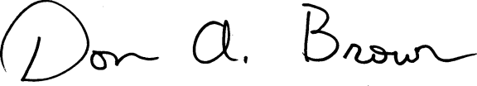
Don A. Brown, Clerk
Illinois Pollution Control Board

